Writing tasks
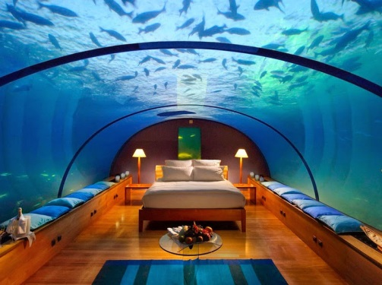
Imagine you had all the money in the world and you were asked to design your ultimate bedroom. Would it be built like a treehouse? Have slides into the bed? Be under the sea? You can be as creative and imaginative as you like. Describe this bedroom in precise detail, being certain to use powerful language that really grabs the attention of the reader.
We all know how important keeping fit and healthy is. The holidays are a great time to increase the amount of exercise that you do and perhaps to try a new sport or activity. Write a short explanation of how to improve your fitness, using the headings below.

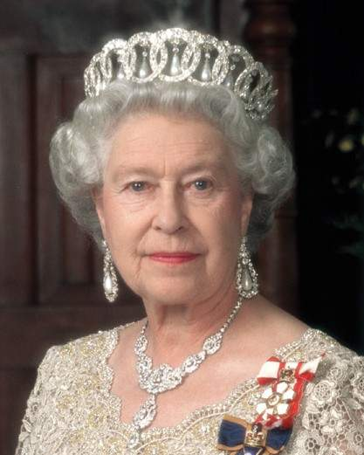
What do you think the Queen talks about over tea? Does she discuss the weather or how her day was? Perhaps she tells Prince Charles off for leaving wet towels in the bathroom? Imagine that the Queen is having tea with her family. Write the conversation that you think they might be having. Remember to include descriptive sentences too, to give the reader more detail.

Who is your hero? Why are they your hero? What would you say to them if you got the chance? Write a letter to your hero, explaining who you are and why they are your hero. Talk about how they have influenced your life and your hopes for the future.

It is the end of the weekend/holidays. Why do they never feel long enough? What if you could persuade your teachers to give you an extra day/week off? Come up with three key reasons that you deserve an extra day/week of holiday/weekend. Explain these reasons and use your language choices to encourage your teacher to agree with you!

