Key questions:
Who the ancient Maya people were? When, where and how did they live? What are the religious beliefs and rituals of the ancient Maya people? How did the Maya feed? What is the significance of corn and chocolate?
Important dates in history: *all dates are approximate * BC (Before Christ) * AD (Anno Domini- after the Christ)
2000BC | The Mayan civilisation emerges in Central America.
100BC | First city states appear.
250AD | The ‘classical’ period begins, urbanisation begins and continues.
300AD | Maya settlements become centres of trade for items such as stone and chocolate.
600AD | Mayan settlements support an increasing population, growing at a fast rate due to plentiful food supply.
650AD | Caracol, one of the main Mayan cities is increasingly populated and expands over a large area becoming an important centre.
900AD | Mayan centres become less important, perhaps because of a widespread drought, but no clear reason has yet emerged.
Key vocabulary |  |  | 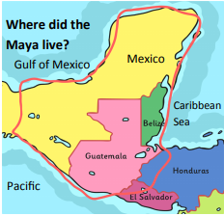  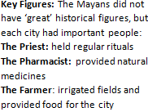  :
Archaeologist: someone who digs up remains of old societies.
Base 20: a maths system based on 20, not 10 like we use.
Codex: an illustrated book made by the Maya.
Civilization: a society with a system of government, laws and records.
Empire: a group of peoples under one leader or government.
Hieroglyphics: pictures or symbols used to represent words for writing.
Jade: a hard stone usually green and used by the Maya to make jewellery
Limestone: rock that is soft enough to dig out the earth, but then quickly hardens. It was used by the Maya and it is still used for building.
Maize: a grain that is common in Central America.
Merchant: a person who buys and sells goods.
Meso-America: the region of central America where the Maya lived.
Pok-ta-pok: a popular sport sometimes used to settle disagreements.
Pyramid: steep buildings to celebrate gods, or perform sacrifices.
Sacrifice: giving of ‘gifts’ to gods, often killing animals or letting blood.
Scribe: a person who copies out documents or writes down the words of others.
Stelae: tall sculpted monuments.
Xibalba: the name of the Mayan underworld. The Maya believed that some people went here when they died.
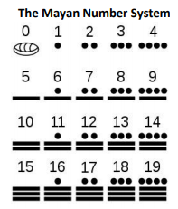 |  | Did you know…?
- The Mayas developed a writing and number system; studied and charted the stars and planets; invented three complex calendars to keep track of time and skilfully farmed the land.
-The Mayans believed in three realms – heaven, earth and the underworld.
-The Mayan civilisation did not abruptly collapse, it was a slow decline.
-In Copan, there are 2,200 glyphs representing the major rulers of the Copan dynasty. It is the l
-The Mayans created spectacular temples and pyramids without the use of metal tools, wheels and domesticated beasts.
Output:
- Create a fact file about when and where Mayas used to live as well as their important discoveries.
- Debate and write a balanced argument text about the significance of corn and chocolate to the Ancient Maya people.
- Research and write a non-chronological report about the documentation recorded by the American explorer John Lloyd Stephens and the British artist Catherwood (they explored the Maya city of Copan).
Year 6 History Knowledge Organiser Topic: The Mayans

