FUDGE
At North we understand that we must prioritise the learning and love of reading for several reasons:
- Achievement: Research shows that children who enjoy reading achieve more highly right across the curriculum. Developing a love of reading is one of the most effective ways a school can raise attainment. Success in reading can improve national test results in all areas but, more importantly, it also sets children up as readers for life, with all the accompanying benefits that follow.
- Entitlement: Every child deserves the chance to become a reader. For many children, including those growing up in a household where reading is not valued, school will be the key place where they come into contact with books. Children who are not introduced to books are missing out on a lifetime of enjoyment. If we fail to do this, the consequences for children are stark. We know that links can be demonstrated between, for instance, illiteracy and offending.
- The National Curriculum: The National Curriculum for English at key stages 1 and 2, places reading for pleasure at the heart of the English curriculum. Alongside the expectation that all children learn to read well, schools are being expected to develop a love of reading in every child. This is difficult if we don’t work together
- Expanding children’s experience: Reading is a passport to the world. The benefits of reading go beyond the opportunities offered by being well-read with a good command of English. Reading great literature opens children up to ideas, experiences, places and times they might never otherwise experience in real life. Reading for pleasure gives opportunities to learn about a multitude of things that cannot be covered by a school curriculum.

Who?
Fathers, uncles, dads, grandads, everyone (including; mums, aunties, sisters, brothers, grandmas)! All family members and friends!

What?
We want to increase the number of children engaging in reading at home with parents and the number of children reading for pleasure.

Why?
Benefit of more time spent reading
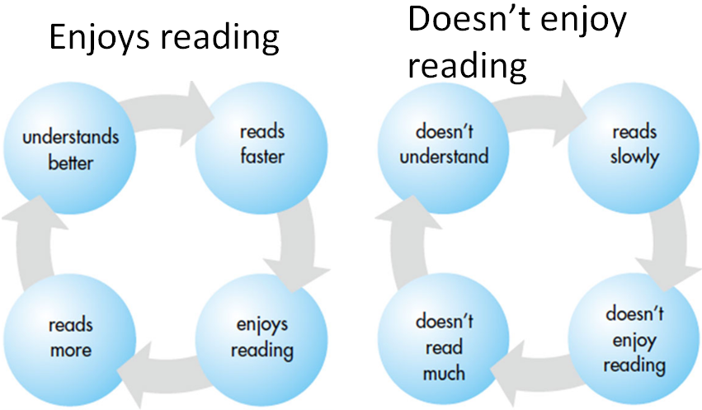
Benefit on Vocabulary
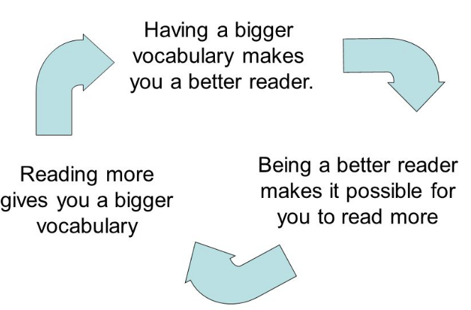
Research has shown a direct link between wide vocabulary and greater academic and financial success later in life. We know that pupils who enter school with limited speaking and listening vocabulary - high performing five year olds - will have an oral vocabulary of about 14,000 words which is almost twice as much as low performing pupils and that gap gets wider each year.
‘After the age of seven, the majority of new words we learn come from reading. Encourage children to read as much and as widely as possible.’
‘A pupils who reads 20 minutes per day outside of school reads almost two million words a year. A pupils who reads less than a minute per day outside of school reads only around 8,000 to 21,000 a year. ‘ James Clements – director of Shakespeare and More.

Benefit of male reading role models
There’s good evidence that children from less well-off backgrounds – and boys especially – are falling behind in their reading.
It’s also the case that dads read less with their children than mums do.
Fathers who are involved in their children’s early education have a significant impact on attainment and on future aspiration. Several reliable studies have shown that high levels of interest by a father in his child’s schooling and education are associated with improved outcomes, including:
- Better exam / test / class results
- Higher educational qualifications
- Greater progress at nursery/school;
- More enjoyment of nursery/school
- Higher educational expectations;
- Better behaviour AND reduced risk of suspension or expulsion

Conversely, low interest by fathers in their children’s education (particularly boys) has a stronger negative impact on their achievement than contact with the police, poverty, family type, social class, housing tenure and child’s personality.
Research tells us that fathers – and mothers – want engagement with their children’s learning and education. Children want this too.
See the article on male reading role models for more information on the positive impact this can have on children’s progress.
Benefit of reading for pleasure
Research into reading shows that developing positive attitudes towards reading play a key role in children’s development:
‘Young people who enjoy reading very much are three times as likely to read above the level expected for their age as young people who do not enjoy reading at all.’
Children’s and Young People’s Reading in 2015, National Literacy Trust
Research also shows that reading for pleasure has a positive impact on children’s attainment in reading assessments. Children who read for pleasure have enhanced levels of text comprehension, an increased knowledge of grammar and show improvement in their writing. Research has found children who read often at the age of ten perform better than their peers in tests of spelling, vocabulary and even mathematics when tested at the age of sixteen. They also have more positive attitudes towards reading than their peers. In fact:
‘Developing a love of reading can be more important for a child’s educational success than their family’s socio-economic background.’
Organisation for Economic Co-operation and Development (OECD)
The advantages of reading for pleasure go beyond academic achievement:
‘Other benefits include an increased breadth of vocabulary, pleasure in reading in later life, a better understanding of other cultures, better general knowledge and even ‘a greater insight into human nature’.’
Reading for Pleasure: A research overview, National Literacy Trust

How?
- Read to children as well as have them read to you – show them that you are a reader!
- Make it a part of your daily routine within your family and with friends (you can use the questions on our website with your child)
- Do it together as a family (Audiobooks, CBBC bedtime stories, Jackanory https://www.bbc.co.uk/iplayer/episodes/b00jdlm2)
- Don’t let language get in the way! Read to them in your home language, listen to audio-books and stories together, show them you are a reader!
- Celebrate – just like in school, celebrate at home, reward, and positive praise will build children’s enjoyment and satisfaction when reading.
- Oversee, monitor and record – ensure you have an on-going dialogue with teachers and the school (reading record). Ask teachers how children are getting on and is there anything you could be doing to further support.
- Must reads –try and ensure your child/children are reading these – talk about them and get them talking with their friends about them
- Local library – register and visit – the more books in your home the better
- Library books – ensure your child is utilising our school library – they can have two books out at any one time so make sure they have them on the go!
- Let them choose! Magazines, newspapers, comics, graphic novels, information texts, recipe books – if they want to read it, let them!
- Home library – have your own home library area that gives the whole family access to texts. The more texts the better (also helps not to lose borrowed books)!

What should children read?
Fiction
Recommended reading – see lists for year groups
Library books
Must-reads – see samples
Comics and graphic novels - Beano, Dandy, Tintin, Asterix, Marvel for kids weekly,
If it interests them let them read it! We want children to read for pleasure!
Non-fiction
Magazines and newspapers
Scoop
1st news (available on school website)
The week magazine
National geographic kidz
Websites (must be overseen by parents)
Annuals – Guinness World records, Rupert bear, Match Football – Have a look at the listof WH Smoths annuals – you can then get these 2nd hand quite cheaply.
Children’s favourite authors (there are many more!)
KS1: Roald Dahl, David Walliams, Jeff Kinney, Francesca Simon, Julia Donaldson, Anthony Browne, Janet & Allan Ahlberg, Emily Gravett, Jackie Morris, Mini Grey, Philip Pullman, Oliver Jeffers.
KS2: Roald Dahl, David Walliams, Anthony Horowitz, Charlie Higson, Michael Muchamore, Neil Gaiman, Chris Riddell, Terry Pratchett, Malorie Blackman, C.S Lewis, Enid Blyton., Michael Morpurgo, Cressida Cowell, Garth Nix, Jacqueline Wilson.

