Key questions:
What influence did the Romans have on our lives today? Why did the Romans invade Britain? Why did they leave?
Important dates in history:
54BC | Julius Caesar leads two Roman armies to Britain, but defeated by Celts both times.
00AD | Christian belief that Jesus Christ was born
AD43 | Roman Emperor Claudius orders four legions to conquer Britain
AD48 | Romans have now conquered large parts of Britain
AD47 | Romans force their allies- Iceni tribe of East Anglia- to give up their weapons
AD 48 | Romans make Colchester the capital of Roman Britain.
AD 61 | Queen Boudica leads a rebellion of the Iceni against the Romans. After burning down Colchester, London and St Albans, Boudica was eventually defeated.
AD 100 | Most of the 8,000 miles of Roman roads in Britain are completed, allowing armies and goods to travel easily across the country.
AD 122 | Emperor Hadrian builds a wall across the border of Scotland- the Romans could not conquer the Scots and Picts.
AD 250 - 409 | The Picts from Scotland, the Angles, Saxons and Jutes from Germany and Scandanavia start threatening Roman lands.
AD 410 | The end of Roman Britain.
Key vocabulary |  |  | 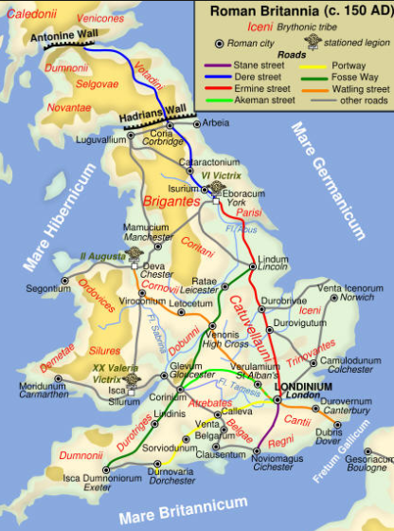
Latin- language spoken and written by the Romans.
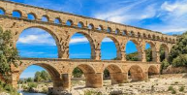
AD- Latin for ‘Anno Domini’= ‘in the year of our Lord’. After Jesus was born.
BC- ‘Before Christ’
Aqueduct- a system of pipes and channels used to bring water into towns.
Centurion-an officer commanding about 80 legionaries/ soldiers.
Legion- the main battle unit of the Roman army
Celt – people who lived in Europe and Britain who fought Romans.
Barbarian- a person who lived outside of the Roman Empire- seen by Romans as violent and uncivilised.
Rebellion/revolt – resistance against the established leaders.
Hypocaust-Roman central heating. Hot air from a furnace flowed through gaps in walls.
Empire- nations ruled over- usually conquered through war.
Villa-a large house in the country
Conquer – To take control of a place by fighting.
Mosaic – A picture made of tiny tiles. The Romans used mosaics in their villas.
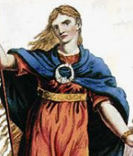 |  | Key Figures:
Hadrian – built a wall on the border of Scotland to keep Scots out- the only tribes not defeated by the Romans.
Boudica- Queen from Iceni who led revolts against the Romans.
Julius Caesar- famous Roman leader in Rome. Was assassinated.
Claudius- Roman emperor who conquered Britain in AD 43 with 40,000 troops and many war elephants.
Output:
- To recount the founding of Rome
- Write a passage as Julius Caesar explaining why he chose to invade Britain.
- Construct a diary entry about a day in the life of a Roman Soldier. Contrast with a member of Boudica’s army.
- Write a persuasive letter explaining the need for Hadrian’s Wall.
- Research and present the legacy of the Roman occupation of Britain.

