Out of This World Curriculum

Curriculum: Who learns what, where, when and how

Context:
99.2% pupils are from an Ethnic Minority
20.1% are entitled to FSM
1.5% EHCP
Very high deprivation and number of children with no right to remain

At North we have developed an ‘Out of this World’ foundation curriculum because:
We believe it is important to introduce children to experiences that they otherwise are unlikely to have, i.e. our project with the Orchestra of the Enlightenment, trips to key London Museums/Galleries. We believe in the value of real life learning experiences in developing children’s understanding.

We have clearly identified the knowledge that our children should be taught in each subject, using the national curriculum as our basis. We have mapped out the sequence of it’s content.
.
Our curriculum is vocabulary rich as our children mostly learn English as an additional language - key topic vocabulary is identified and explicitly taught through the topic and across subjects. There is also an explicit approach to teaching academic language.

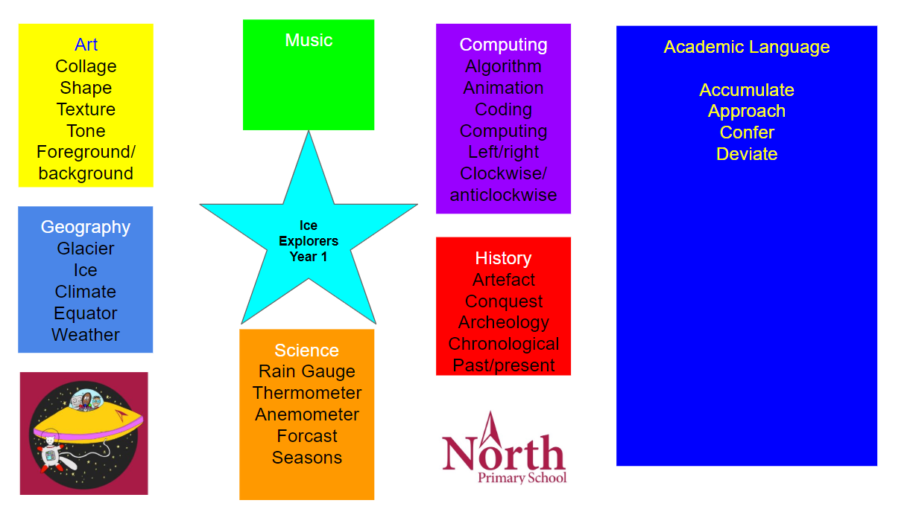
We identify what we want the children to know and record this on a knowledge organiser as an aide memoire for pupils and for their parents to be able to contribute to their learning.
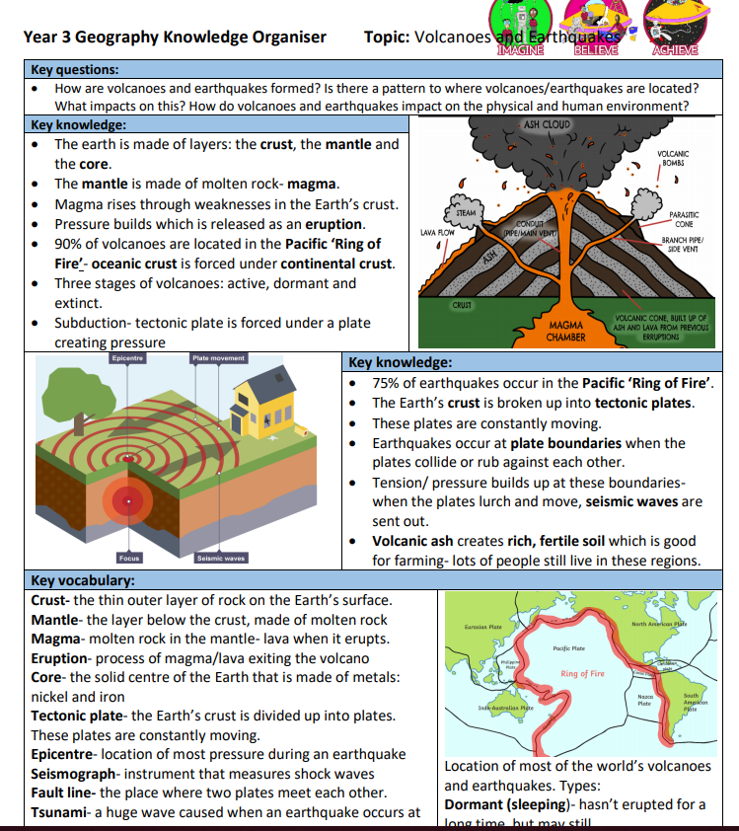
We utilise different strategies of retrieval practice to ensure that this new knowledge is embedded and learnt.

We believe in mastery of skills across the curriculum:

Mastery - comprehensive knowledge or skill in a particular subject or activity.
"she played with some mastery"
synonyms: | proficiency, ability, capability
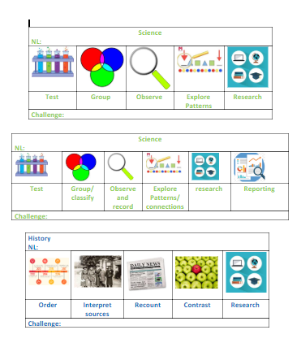
Skills are learnt in context - the relevant subject skills are explicitly identified in each lesson on the success criteria.

The wider curriculum enables children to develop fluency of basic skills - reading comprehension is a current focus for the school.

Learners develop subject thinking - ie musical thinking is central to deep and sustainable learning of music.

Taught knowledge is understood deeply and not just ‘received’ passively but worked on by the learner. It is thought about reasoned and discussed.

Thinking in the wider curriculum involves:
- Looking for patterns
- Comparing and contrasting
- Explaining
- Evaluating

The topic approach to learning is used, where this makes sense, because:
It helps the children see the links between the subjects.
It’s more fun to teach and learn using a theme

The impact of our curriculum is measured through:
Engagement in lessons
Books
Core subject attainment data - due to increased vocabulary and rehearsal of basic skills
Pupil voice
Use of end of Key Stage Assessment Frameworks to evaluate pupils’ age related expected and greater depth outcomes

