Year 5 Geography Knowledge Organiser Topic: A comparison of the UK and Spain.
Key questions:
- What differences are there in the physical features of Spain and the UK?
- What is the difference in the climates of Spain and the UK?
- What animals inhabit each nation?
- What foods do they eat in Spain? UK?
Key knowledge: |  | 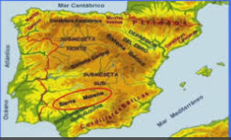
Physical features of Spain:
- Third largest nation in Europe.
- A coast line spanning 3000 miles.
- There are five regions in Spain: Green Spain, Inland Spain, the Pyrenees, Southern Spain and Mediterranean Spain.
- Green Spain: located in the north/northwest wet, evergreen climate. Rock and steep coastlines.
- Inland Spain: dry climate like a dessert
- Pyrenees: mountain range stretching 260 miles long bordering France. Rivers, glacial lakes and small pains
- Southern Spain: weather varies, there is a snowy location but also a dessert.
- Mediterranean Spain: borders the Mediterranean Sea. There is a tropical part and has few islands.
Spain has unique geographical features contributing to the development of their culture.
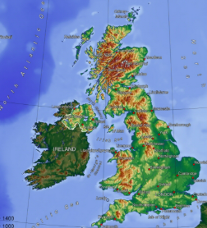 | Key knowledge:
Physical features of the UK: Comprises most of the central and southern two-thirds of the island of Great Britain, in addition to a number of small islands of which the largest is the Isle of Wight. England is bordered to the north by Scotland and to the west by Wales. It is closer to continental Europe than any other part of mainland Britain, divided from France only by a 33 km (21 mi) sea gap, the English Channel. The 50 km (31 mi) Channel Tunnel, near Folkestone, directly links England to mainland Europe. The English/French border is halfway along the tunnel.
Much of England consists of low hills and plains, with upland and mountainous terrain in the north and west. Uplands in the north include the Pennines, an upland chain dividing east and west, the Lake District, containing the highest mountains in the country, the Cheviot Hillsacross the Anglo-Scottish border, and the North York Moors near the North Sea. Uplands in the west include Dartmoor and Exmoor in the south west.

Key knowledge:
Climate of Spain  There are three different climate zones in Spain, due to its large size. Visitors can generally expect a Mediterranean climate, characterized by hot, dry summers and mild, rainy winters. The vast central plateau, or Meseta, has a more continental influenced climate with hot, dry summers and cold winters. Rain generally falls mostly in spring and autumn. The mountains surrounding the plateau have a higher rainfall and often experience heavy snowfalls in winter.  Climate of the UK  Warm summers and cool winters. Summers are cooler than those on the continent, but the winters are milder. The overall climate in England is called temperate maritime. This means that it is mild with temperatures not much lower than 0ºC in winter and not much higher than 32ºC in summer  . |  |  | 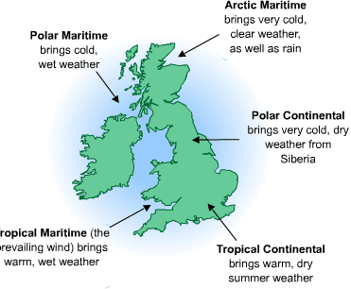
Animals in Spain  The Mediterranean or Iberian lynx is almost extinct, there are only a few surviving mammals left in the south of Spain and Portugal. The lynx is the most endangered cat in the world.  Other protected animals are the Iberian wild boar, the Iberian fox, the Iberian wolves and the Cantabrian brown bear.  The short-toed eagle is Spain's national bird. The region of Andalusia is home to the Andalusian horses which are known for their speed and strength.  Animals in the Uk  The UK is fortunate to have diverse animal species. On top of the thousands of invertebrates found here, there are also numerous vertebrates inhabiting the country. In fact, all five vertebrate groups are well-represented in England. |  |  | 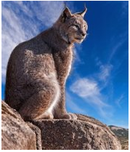
Food in Spain  The Spanish main dishes contain: potatoes, rice, fish, meat, beans, chickpeas and fruit. Here is some typical Spanish food:  - Paella: A rice dish with seafood or meat such as rabbit, chicken and snails, popular especially in Valencia  - Gazpacho: Vegetable soup or stew  - Coca: A sweet bread  - Empanada: Stuffed bread or pie  - Turrón: Nougat sweet cake made with honey and nuts  - Jamón Serrano: Pork leg ham  - Chorizo: Pork sausage  Food in the UK  Fish and chips, A Sunday Roast, shepherd’s pie and bangers and mash are all seen as traditional British food |  |  | 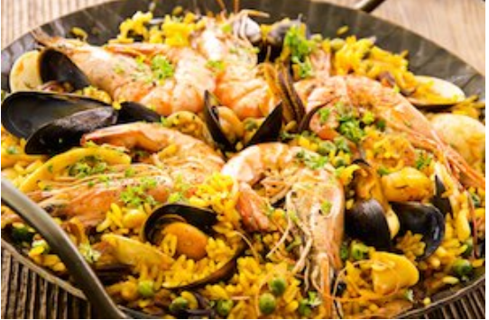
Output:
- Contrasting physical features of the UK and Spain.
- Designing housing appropriate for both locations.
- Designing a menu for restaurants in both nations.
- Case study of different animals in each location.

