Year 2 Science Knowledge Organiser Topic: Plants
Key questions:
How do plants grow? What does a plant need to grow and stay healthy? What are the parts of a plant? How are plants related to science? Do plants grow better in soil or water? What is the life cycle of a plant?
Key knowledge | The life cycle of a plant
- Plants are living things.  - Most have roots which they use to absorb water and nutrients, and leaves which they use to absorb sunlight.  - Plants come in many different shapes and sizes, and live in different habitats around the world.  - Plants are part of the food chain and many are eaten by animals.  - Seeds are spread out (dispersed) in various different ways such as wind and animals. | 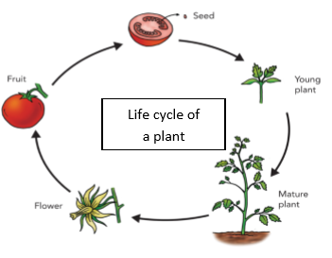  Life cycle is a series of changes living things go through.  1. The plant grows.  2. The flower blossoms and then dies.  3. A fruit with seeds is left behind.  4. The seeds get scattered.  5. The process begins again.
Key knowledge: Parts of the plant and their functions.
- Roots: hold the plant in the ground and absorb water and nutrients from the soil.  - Stem: transports water and nutrients to different parts of the plant.  - Leaves: use light, air and water to make food for the plant.  - Flower: the part of a plant that blossoms. Flowers produce the seeds that form new plants.  - Petals: attract pollinators using their bright colours or unusual shapes.  - Trunk: the stem of a tree, from which its branches grow.  In order for a seed to survive and grow into a strong plant it needs water, light, suitable temperature, air and time.  - Seeds: the part of a plant from which a new plant grows. | 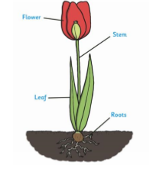  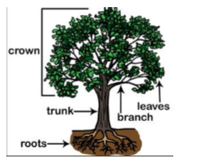
Key vocabulary:
- Fruit: a usually sweet food (such as a blueberry, orange, or apple) that grows on a tree or bush. Fruits contain seeds. Fruit is sweet so is tempting to animals who it and poo out (excrete) the seeds.
- Vegetable: the other edible parts of the plant (like stems, flower buds, leaves).
- Carbohydrate: foods that give you energy, such as potatoes, bread, rice, pasta.
- Dairy: food that that provide calcium, such as milk, cheese, yogurts and cream.
- Protein: food that stops you becoming poorly, such as beans, eggs, meat and fish.
- Bulb: A sort underground stem surrounded by usually fleshy modified leaves that contain stored food.
- Pollen: the product of a male part of a plant which allows it to produce seeds.
- Pollination: the process by which pollen is transferred to the female parts of the plant which means the plants can make seeds and reproduce.
- Germination- where a seed first sprouts – the beginning the growing cycle.
Output:
Explain using diagrams and labels, the different parts of a plant.
Observing how seeds and bulbs grow.
Fair test: how do we keep a plant healthy? Test the conditions needed to keep plants alive and healthy.
Using magnifying glasses to observe the inner part of a flower.
Comparing how different plants and seeds grow.
Writing the results of a comparative test.

