Year 4 Science Knowledge Organiser Topic: Electricity
Key questions:
- What components are needed in a circuit in order for it to work properly? What everyday appliances need electricity in order to work? Why would you put a switch in a circuit? What do we notice about the materials that conduct electricity? What do we notice about the materials that insulate electricity?
Key knowledge: | 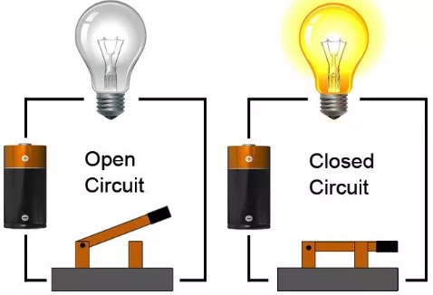  In both circuits we can see they have a source of electricity (battery).  The circuit on the right is a closed circuit, meaning the electric current will flow and therefore the bulb will light up.  The circuit on the left is an open circuit, meaning the electric current cannot flow and the bulb will not light up.
- Electricity makes all sorts of everyday appliances (like computers, mobile phones and radios) work.
- In a circuit electricity flows through wires to make components like bulbs, buzzers and motors work. Electricity comes from a power source which is often known as a cell.
- A circuit will only work if there aren’t any gaps in it and everything is connected properly. Every circuit also needs a power source to work.
- For a component to work in a circuit, it needs to be part of a complete loop that starts and ends a cell.
- Using electricity can be dangerous. A shock from a mains socket could kill you. Take care and follow some safety guidelines to keep safe.
- A switch lets you turn a circuit on and off. When switches are closed, electricity can flow and the circuit is ‘on’. When the switches are open, electricity cannot flow and the circuit is ‘off’.
- If something is a good electrical conductor this means electricity passes through it easily. If something is a good electrical insulator electricity doesn't pass through it.
Key vocabulary:
Electricity - Electricity is an energy. This energy can be used to power electrical items such as toasters, kettles, cookers, televisions and computer tablets.
Circuit - A circuit is a complete path around which electricity can flow.
Electrical component - A part in an electrical circuit, e.g. a switch
Switch - Switches are used to control circuits. They can break a circuit - and so switch bulbs, motors and buzzers off - or complete a circuit - and so switch them on again.
Current - This is the amount of electricity flowing through the circuit (basically a flow of electrons moving in a loop in the circuit).
Battery - A battery is a source of energy which provides a push - a voltage - of energy to get the current flowing in a circuit.
Bulb - A component of a circuit that will light up when connected properly.
Plug - A device usually on a cord used to make an electrical connection by putting it into another part (as a socket)
Appliance - A device, machine, or piece of equipment, powered by electricity.
Conductor- Conductors are made of materials that electricity can flow through easily such as metals.
Insulator - Insulators are made of materials that electricity cannot flow through easily such as rubber and plastics. Wires have a metal core and a plastic outer casing for this exact reason!
Output and Working like a scientist:
- To identify a range of circuits and explain whether they allow an electrical current to flow or not.
- To construct a simple series electrical circuit, identifying and naming its basic parts, including cells, wires, bulbs, switches and buzzers
- To construct a circuit and test to see how easily you can break and reconnect a circuit
- Test materials to investigate if they are insulators or conductors.
- Test different ways that we can make a lightbulb brighter.
- To record or results and findings from investigations in various ways e.g. Tables, bar graphs and line graphs.

