Year 5 Science Knowledge Organiser Topic: Living things and their habitats.
Key questions:
- What are the differences in the life cycles of a mammal, amphibian, insect and a bird?
- What is the life process in the reproduction of plants?
- What is the life process in the reproduction of animals?
Key knowledge: |  | 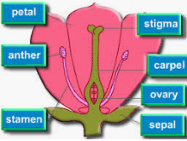
Plants are able to reproduce in two different ways - sexual reproduction and asexual reproduction.
- Sexual reproduction in plants happens in a cycle-like pattern. Flowers come from seeds, and they create seeds too. All flowering plants go through the following life cycle.
- Germination is the process by which a plant begins to grow from a seed. Roots form under the soil. The stem, leaves and flower emerge above the soil.
- Pollen produced by a flower is carried by insects or blown by the wind to another flower. This process is called pollination.
- When the pollen reaches another flower, it travels to the ovary where it fertilises the egg cells to make seeds. This process is called fertilisation.
- These seeds are scattered by animals or the wind. This process is called dispersal. Some of the seeds will grow into new plants.
Asexual reproduction happens when plants produce bulbs, like daffodils and snowdrops

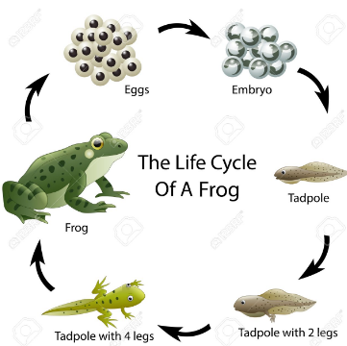 | Key knowledge:
- Amphibian life cycle (frog): Like humans, frogs undergo life changes. This doesn’t happen overnight and there are four main stages.
- 1) Eggs- a mass of soft, jelly coated eggs that stick to plants in water. They soon hatch into tadpoles. 2) Tadpoles-like fish that swim in water and have gills to breathe. They grow quickly with a long tale. They eat algae or tiny organisms in the water. 3) Froglet- Legs sprout from the tadpoles body and its tail becomes smaller. That tail is absorbed into the body. Lungs develop allowing it to breathe in and out of water. 4) Frog- Eleven weeks after the eggs are laid, a fully developed frog emerges from the water.
- Insect life cycle: These animals have a different type of life cycle. Some insects have a four stage life cycle. The insect lives in an egg, larva, pupa and an adult.
Key knowledge:
Life cycle of humans:  There are six stages in the human life cycle:  1. Foetus- At this time, a baby is growing inside its mum's womb.  2. Baby- A baby is born after spending nine months inside the womb.  3. Childhood- At this stage, you learn to walk and talk.  4. Adolescence- Children become teenagers.  5. Adulthood-Your body is fully developed.  6. Old age-The last stage in the life cycle of a human. |  |  | 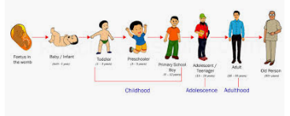
Output:
- Dissecting a flower. Capture the key structure of a flower and its life cycle.
- Describe the life process of reproduction in some plants and animals. Investigate ways that plants reproduce asexually
- Describe the differences in the life cycles of a mammal, an amphibian, an insect and a bird.
- Describe the life process of reproduction in some plants and animals.

Working like a scientist:
- Record data and results of increasing complexity using scientific diagrams and labels.
- Identify scientific evidence that supports or refute ideas or arguments.
- Plan different types of scientific enquiries to answer questions, including recognising and controlling variables where necessary.
- Identify scientific evidence that has been used to support or refute ideas or arguments.

