Year 6 Science Knowledge Organiser
Topic: Blood circulation and staying healthy
Key questions:
- What are the functions of the following organs: heart, veins, arteries, lungs and capillaries?
- What is the impact of regular exercise important on our body?
- What are the effects of tobacco to our body?
- How does the body get rid of waste?
Key knowledge: The circulatory system |  | Circulatory System Parts of the Lungs  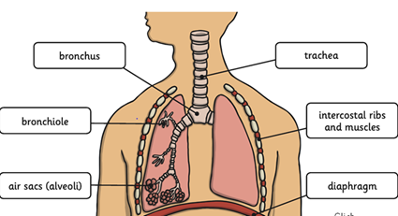  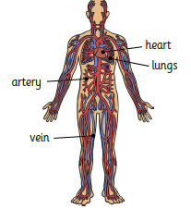  Haemoglobin in blood is a red protein that helps to carry oxygen and the mineral iron around the body.
- The word circulation means ‘the movement to, fro or around something’. Blood circulation describes the way blood goes round and round the body.
- All parts of the body are connected by tubes called blood vessels. Blood vessels take blood round the whole body. When the blood visits the intestines it picks up water and dissolves food. It then moves on the circulatory system, carrying them along in the blood.
- Inside the blood vessels are red blood cells which give blood its red colour . Blood rich in oxygen is redder, compared to blood with low oxygen which is slightly bluer.
Parts of the Heart  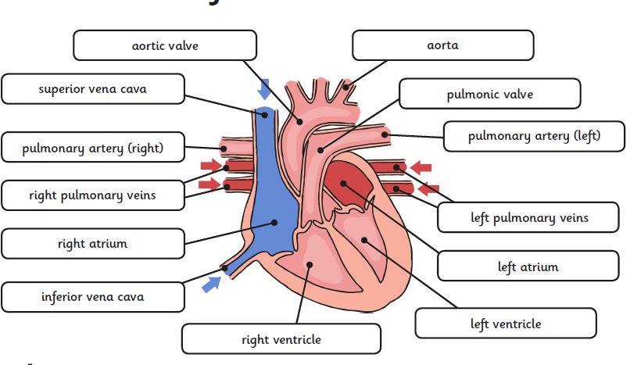 | Key knowledge: General Functions of the circulatory system
 | 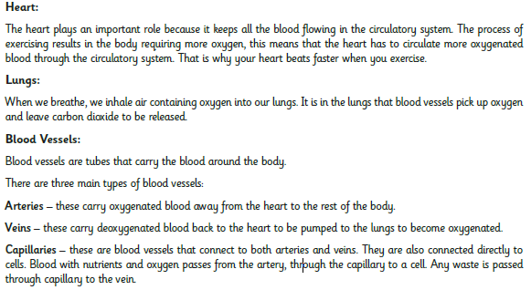
Key knowledge: How the body get rid of waste? |  |  | 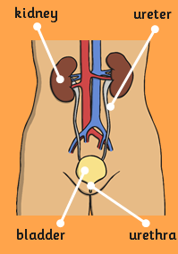
Kidneys are responsible for getting rid of waste from blood in two ways.
- Veins collect waste from cells. Most of the waste is realised into the liver. The liver then uses it to create bile. This goes into the duodenum to break down food into chyme. The waste that is not turn into bile is made soluble (dissolves in water) and goes into the kidney.
- The kidneys perform a function called filtration. The renal vein delivers blood to the kidney which it filters for waste. This is called ultra-waste and is turned into urine which is passed through the bladder. The bladder sends signal to the brain that urine needs to be expelled. Urine is then released through the urethra.

Key Knowledge : The impact of regular exercise
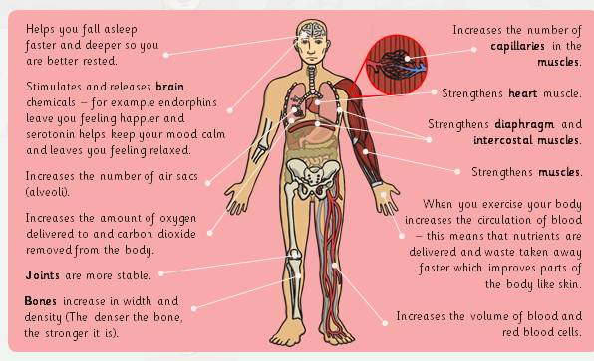
Along with exercise, a healthy, balanced diet is how top athletes such as Lionel Messi and Harry Kane stay in peak physical condition. Staying healthy means keeping a healthy body, but also keeping a healthy mind and making a range of positive lifestyle choices including food, exercise, sleep, no drugs and positive relationships.
Key vocabulary:
Arteries – Muscular-walled tubes that transport blood from the heart to other parts of the body
Blood – Red liquid that circulates in arteries and veins, carrying oxygen to and carbon dioxide from tissues of the body
Circulatory system – The system that circulates blood through the body, including the heart, blood vessels and blood
duodenum
Heart – A hollow muscular organ that pumps the blood through the circulatory system
Lungs – Pair of organs situated within the ribcage where oxygen can pass into the blood and carbon dioxide be removed
Muscles – A band or bundle of fibrous tissues that have the ability to contract, producing movement in or maintaining positions of parts of the body
Nutrients – A substance that provides nourishment essential for the maintenance of life and for growth
Veins – Tubes forming part of the blood circulation system of the body, carrying mainly oxygen-depleted blood towards the heart
Drugs- can be legal and illegal. Legal; drugs include medicines which should only be taken when presecribed by a doctor. Legal drugs also include alcohol and tobacco – these have age-restrictions on them because if used incorrectly, can have negative health effects. Illegal drugs, such as marajuana are often addictive and can lead to a range of negative health effects incluing mental health issues and damage to organis in the body.
Output & Working like a scientist:
- A fact file describing the functions of the circulatory system.
- Write a ‘job description’ about the function of the heart
- An explanation report about the circulatory system
- A non-chronological report about healthy life style ( Drugs , exercise , alcohol)
- Working scientifically: How is exercise and pulse rate linked?
- Calculate the average pulse rate before and after exercise and record using statistics, making comparisons.

