Year 1 Science Knowledge Organiser Topic: Animals including humans
Key questions:
- Is there a pattern to where volcanoes/earthquakes are located? Wat impacts on this?How do volcanoes and earthquakes impact on the physical and human environment?
Key knowledge: |  | 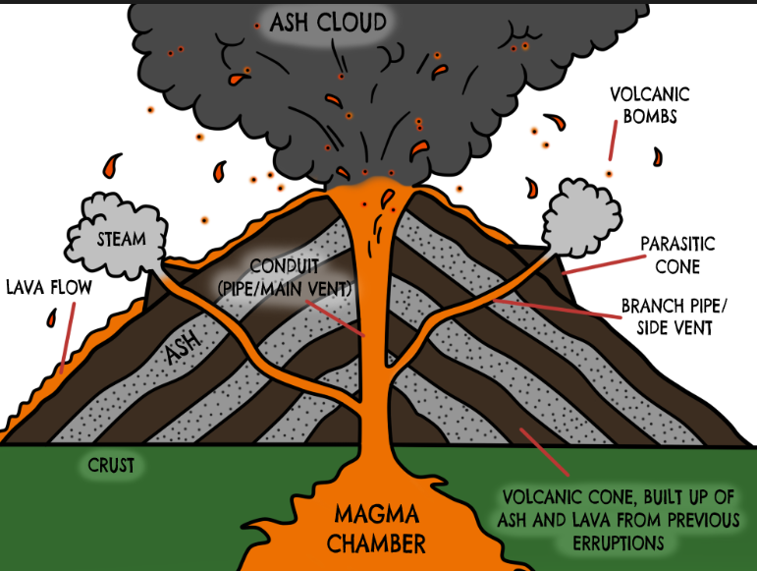
- The earth is made of layers: the crust, the mantle and the core.
- The mantle is made of molten rock- magma.
- Magma rises through weaknesses in the Earth’s crust.
- Pressure builds which is released as an eruption.
- 90% of volcanoes are located in the Pacific ‘Ring of Fire’- oceanic crust is forced under continental crust.
- Three stages of volcanoes: active, dormant and extinct.
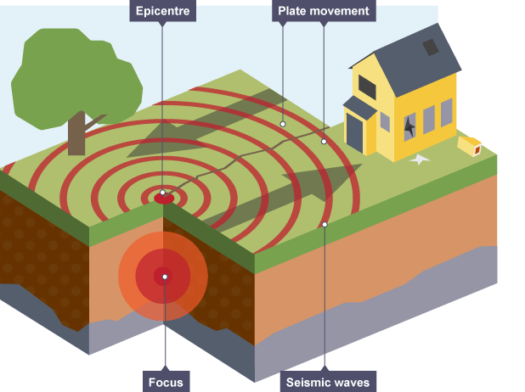 | Key knowledge:
- 75% of earthquakes occur in the Pacific ‘Ring of Fire’.
- The Earth’s crust is broken up into tectonic plates.
- These plates are constantly moving.
- Earthquakes occur at plate boundaries when the plates collide or rub against each other.
- Tension/ pressure builds up at these boundaries- when the plates lurch and move, seismic waves are sent out.
Key vocabulary:
Crust- the thin outer layer of rock on the Earth’s surface.  Mantle- the layer below the crust, made of molten rock  Magma- molten rock in the mantle- lava when it erupts.  Eruption- process of magma/lava exiting the volcano  Core- the solid centre of the Earth that is made of metals: nickel and iron  Tectonic plate- the Earth’s crust is divided up into plates. These plates are constantly moving.  Epicentre- location of most pressure during an earthquake  Seismograph- instrument that measures shock waves  Fault line- the place where two plates meet each other.  Tsunami- a huge wave caused when an earthquake occurs at sea. |  |  | 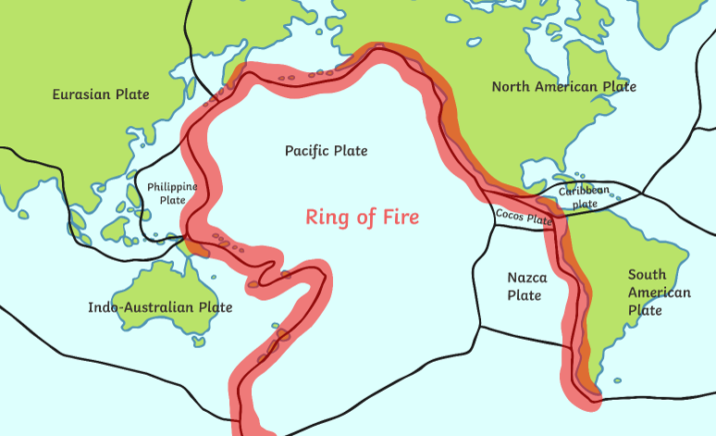  Location of most of the world’s volcanoes and earthquakes.
Output:
By the end of this topic I will have produced a non-chronological report all about volcanoes and earthquakes. I will be able to do the following:
- research information about earthquakes and volcanoes.
- Turn researched notes into my own sentences.
- Present information in an interesting and lively way to inform my reader.
- Use sub-headings and text boxes to organise my ideas.
- Draw and label diagrams.
- Use lots of the vocabulary learnt above in written work and discussion.
Year 3 Science Knowledge Organiser Topic: Rocks and Soils
Key questions:
- What types of rocks are there?
- How are different rocks formed?
- Are the properties of rocks the same or different? What causes these?
Rocks Key knowledge: |  |  | 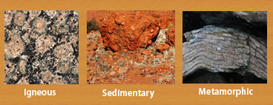
- Sedimentary: grainy in texture, often containing fossils. Crumble easier than other rocks. Created by compacting grains e.g sandstone.
- Igneous: formed from cooling magma/lava. Interlocking grains with crystals e.g granite
- Metamorphic: sedimentary or igneous rock that has been put under extreme heat and pressure to change structure e.g marble.
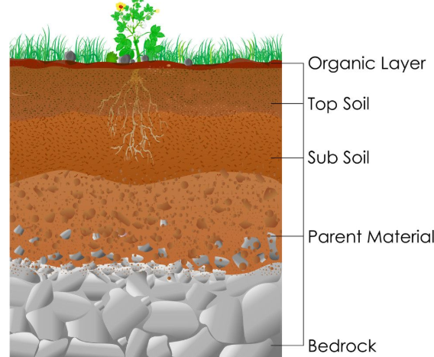 | Soil Key knowledge:
- Half of soil is air and water. Water is in the soil and the air is in the gaps between the particles.
- Soil is made up of millions of micro-organisms, such as worms and other invertebrates that help break down matter.
- Things you might find in soil: sand, small stones, decaying plants and animal matter.

Fossils key knowledge: |  |  |  | 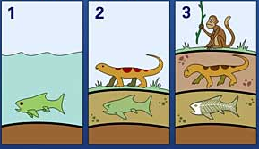
- Plant or animal dies and falls to the bottom of a lake.
- Body is preserved and prevented from rotting/ decaying.
- Over time, sand and mud grains are deposited over the body.
- Grains turn into sedimentary rock around the remains.
- Shape of body is captured in the stone.
- Stone is dug up with an outline of the prehistoric animal/plant.
Key vocabulary:
Sandstone- sedimentary rock made of sand
Limestone- sedimentary rock made from calcium deposits such as shells
Granite- a type of igneous rock formed below the Earth’s surface.
Marble- a type of metamorphic rock. Granite that has been heated and squashed turns into this.
Fossils- remains or impressions of a prehistoric plant or animal embedded in rock.
Permeable- rock with holes in that allows water through e.g sandstone
Impermeable- rock that does not allow water to pass through e.g granite.
Soil- mixture of tiny particles of rocks, plant and animal matter
Output: |  | Working like a scientist:
Produce a non-chronological report on rocks, soils and fossils:  - Research information, make notes and turn notes into my own written sentences.  - Use diagrams and images to present information in an engaging, lively manner.  - Use lots of topical language correctly to explain and info. |  | - Observing rocks, fossils and soil closely using a microscope.  - Explain and reason why they may have changed over time.  - Identify and classify rocks according to their properties.  - Explore how fossils are formed.  - Explain how soil is formed after creating compost.  - Identify similarities and differences between rocks.  - Investigate what happens when rocks are rubbed together.

Key questions:
What influence did the Romans have on our lives today? Why did the Romans invade Britain? Why did they leave?
Important dates in history:
54BC | Julius Caesar leads two Roman armies to Britain, but defeated by Celts both times.
00AD | Christian belief that Jesus Christ was born
AD43 | Roman Emperor Claudius orders four legions to conquer Britain
AD48 | Romans have now conquered large parts of Britain
AD47 | Romans force their allies- Iceni tribe of East Anglia- to give up their weapons
AD 48 | Romans make Colchester the capital of Roman Britain.
AD 61 | Queen Boudica leads a rebellion of the Iceni against the Romans. After burning down Colchester, London and St Albans, Boudica was eventually defeated.
AD 100 | Most of the 8,000 miles of Roman roads in Britain are completed, allowing armies and goods to travel easily across the country.
AD 122 | Emperor Hadrian builds a wall across the border of Scotland- the Romans could not conquer the Scots and Picts.
AD 250 - 409 | The Picts from Scotland, the Angles, Saxons and Jutes from Germany and Scandanavia start threatening Roman lands.
AD 410 | The end of Roman Britain.
Key vocabulary |  |  | 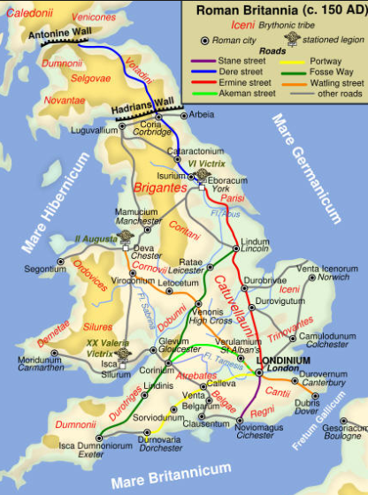
Latin- language spoken and written by the Romans.
AD- Latin for ‘Anno Domini’= ‘in the year of our Lord’. After Jesus was born.
BC- ‘Before Christ’
Aqueduct- a system of pipes and channels used to bring water into towns.
Centurion-an officer commanding about 80 legionaries/ soldiers.
Legion- the main battle unit of the Roman army
Celt – people who lived in Europe and Britain who fought Romans.
Barbarian- a person who lived outside of the Roman Empire- seen by Romans as violent and uncivilised.
Rebellion/revolt – resistance against the established leaders.
Hypocaust-Roman central heating. Hot air from a furnace flowed through gaps in walls.
Empire- nations ruled over- usually conquered through war.
Villa-a large house in the country
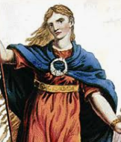  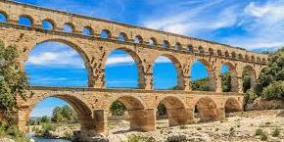 |  | Key Figures:
Hadrian – built a wall on the border of Scotland to keep Scots out- the only tribes not defeated by the Romans.
Boudica- Queen from Iceni who led revolts against the Romans.
Julius Caesar- famous Roman leader in Rome. Was assassinated.
Claudius- Roman emperor who conquered Britain in AD 43 with 40,000 troops and many war elephants.
Output:
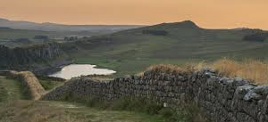
A series of letters that include details of key and significant Roman events in Britain at the time.
- Use layout and key features of a letter.
- Write from the point of view of characters from the time period.
- Include key historical facts, information and words from the time.

Year 3 History Knowledge Organiser Topic: Roman Britain

